**Guide to Tampere**

A detailed guide on migrating from Pakistan to Tampere, Finland

JULY 2024

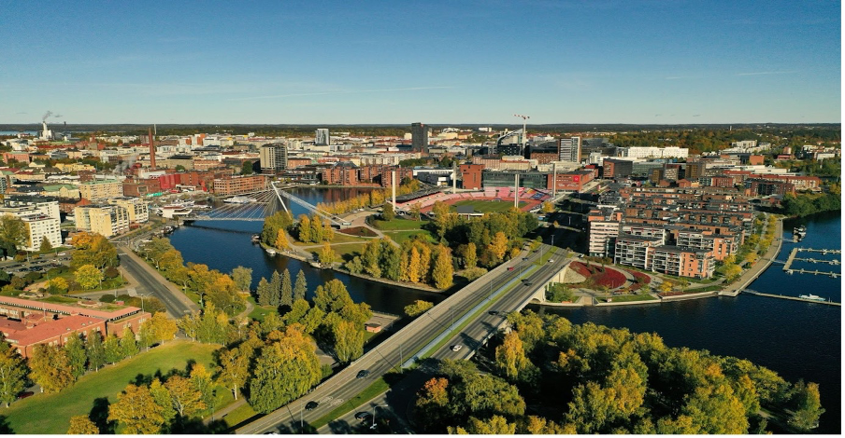

**Table of Contents**

1. **HELSINKI <-> TAMPERE GUIDELINES**

Tikkurila - Tampere

To Tampere From Helsinki Airport

Identification As A Student For VR

1. **SOCIAL SECURITY NUMBER**

What is SSN or PIC?

1. **DVV REGISTRATION**
2. **AUTHENTICATION**

Finnish Authenticator App

1. **INTERNET CONNECTION**

Ethernet/WAN Connection:

DSL Connection:

What to Bring?

Additional Information

1. **INSTRUCTIONS TO USE TRAVEL CARD (NYSSE)**

Payment by Nysse app

Payment by Bank Card

Payment via Nysse Card

# 

# Helsinki <-> Tampere Guidelines

1. Connect to airport wifi.
2. Immigration ~ make sure you have the funds in your account as you might have to show it on your mobile banking app - better to open your mobile banking app before going to the immigration counter.
3. once your immigration is cleared then you can just exit the airport
4. use the washroom if needed before taking your bags from baggage claim as you will not be able to use it once you are outside the airport with all your luggage
5. you will see exit signs just follow them
6. R-kioski ~ it’s a shop from where you can purchase your sim for 5-6€ … you can buy sim of DNA, Telia, and Elisa but I will recommend buying DNA sim and you will get some credit and mbs so don’t worry about the recharge.
7. Follow the VR sign on board and you will reach the railway station directly from the airport, it will be a 5-10 mins walk. Use the elevator to go down on the platform.
8. There will be a route planner on the wall see that and make sure that in which direction your train will be going - you must go to Tikkurila station.

## Tikkurila - Tampere

1. The train will not stop for long at stations and with bags you should be quick to get on and off the trains. The train will take approx 20 mins to reach Tikkurila station and after reaching there you must look for the platform number your train will be coming on.
2. You must have enough time (maybe 30 min) to change trains at Tikkurila station.
3. Again be quick and take the train to Tampere …keep checking your VR app so that you can know the platform number your train will be arriving on.
4. I recommend booking IC trains as they are fast, have washrooms and internet
5. It’s better to contact your tutor and ask him/ her to help you in reaching your apartment from the railway station. Tell them when you will reach and how many bags you have.
6. If your tutor is not available or you are on your own then use Google Maps (i will attach a pic) and see the bus schedules
7. If you are coming to Hervanta then it will be a 3-4 mins walk from the train station to the bus station.
8. Get on the tram and you will reach Hervanta easily …. there will be a card machine on bus and tram so you should pay for your ticket (I will share the method in detail if you need it)

### **To Tampere From Helsinki Airport**

If you're travelling to Tampere via Helsinki Airport, you'll need to change trains at Tikkurila station. Down below are some tips and Important Takeaways to make the transfer easier:

1. Your first train is a commuter train from Helsinki Airport to Tikkurila.
2. The ticket for this train becomes valid a bit earlier than the time listed on your VR ticket. You can recognize this because the ticket will show a green logo instead of a grey one in the app.
3. This means you can catch an earlier train from the airport, before the time listed on your VR ticket.
4. For example, if your ticket shows a start time of 11:04, you can take an earlier commuter train at 10:30 or 10:45. These trains run every 10-15 minutes from Helsinki Airport.
5. By taking an earlier train, you'll have more time to switch tracks at Tikkurila for your train to Tampere, avoiding the rush.

This way, you won't have to worry about a tight connection at Tikkurila station.

## 

## Identification As A Student For VR

Those who are worried or do not know how to identify themselves as students on their first journey at VR Trains. There are two ways:

1. Download the Tuudo App and register yourself. It is free, and you can use it even in uni as well.
2. If you have your email credentials, sign in at sisu, and from there, you can download a student certificate in English and Finnish.



# Social Security Number

## What is SSN or PIC?

**SSN:** Social Security Number

**PIC:** Personal Identity Code

Both are the same thing and it is like the CNIC number that we have in Pakistan

* It’s your kind of identity number so you must keep it safe, remember that number, and never share it with anyone you don’t know.
* You have to use this number almost everywhere officially in Finland.
* SSN/PIC is an 11 digit number that starts with your date of birth followed by a month of birth and then the last two digits of your birth year after that a unique number.
* Example: **241299-XXXX**

Here

* 24 is date
* 12 is month
* 99 is year (1999)
* “-“This is also counted
* and then you may have digits or alphabets instead of that “XXXX”.

you may or may not receive it with your positive positive decision.



# DVV Registration

* Fill out this form if you have…

1. Positive decision and got SSN.

2. you have an apartment/ or address in Finland where you will be living permanently.

<https://lomakkeet.dvv.fi/lomakkeet/6889/lomakkeet.html?rinnakkaislomake=en>

* Fill out this form if you get a positive decision but DON'T have a SSN.

<https://lomakkeet.dvv.fi/lomakkeet/wuY0J/lomake.html?rinnakkaislomake=en>.



# Authentication

## Finnish Authenticator App

Firstly, you have to install the Finnish Authenticator App.

* If it crashes then you'll have to change your Mobile Device.
* In Finish Authenticator App Register with your personal Gmail Account.
* Then use your Passport for Identity Authentication.
* After activating the Finnish Authenticator App Then you can proceed to the Tuni site to activate your Tuni account.
* From their chosen Foreign Authentication Method.
* Then choose the Finnish Authenticator App.



# Internet Connection

There are mainly two types of internet connections available in the apartments:

1. Ethernet/Wan Connection.

2. DSL Connection.

## 1. Ethernet/WAN Connection:

* Direct wall connection for RJ45 cables.
* For TOAS apartments, you only need a router with an Ethernet/WAN port.

## 2. DSL Connection:

* May require a VDSL modem (specifically mentioned if needed).
* The TV plug connects to the wall, and an RJ11 cable plugs into the TV plug.
* POAS apartments typically require a modem/router with VDSL support to enable both internet connection and WiFi.

## 3. What to Bring?

It's recommended to bring the following items:

* A LAN/Ethernet cable, 2-3 meters long (RJ45 cable).
* A DSL cable (RJ11 cable).
* A simple router with an Ethernet/WAN port or a VDSL router with a DSL port. Routers that have both ports are also available. TP-Link offers nice and affordable options.

## 4. Additional Information

* TOAS includes specific router requirements in their offer email and on their website.
* If your apartment type is not specified on the website, bring a router suitable for an Ethernet/WAN connection.
* You may receive a free modem from TOAS, which uses Telia(like ptcl/stormfiber) as the service provider. Please contact them directly to obtain your modem.
* 5ghz wifi routers are better as they more better speeds and reliable connections.
* If you didn’t bring a router from home and one was not provided by TOAS, you can find them on online marketplaces like FB Marketplace or Tori for free or for 10-20eur.
* you won't get a TV plug from Pakistan, yahan se mil jayga from 2nd hand stores or online marketplaces.

SO NOO TENSION



# Instructions to use Travel Card (Nysse)

Instruction to use bus/ tram and card

* In the tram there are many card machines so you can use any.
* **For Buses:** You must get in through the front door and a machine is available near the driver’s side. There will be an area near the back door where you can put your luggage only. Remember, you must vacate that area if there is a baby cart/ pram or a disabled person coming. There are two back doors, and you will exit the bus from those doors only.

## Payment by Nysse app

If you are paying with the Nysse app then open the QR Code and scan it as shown in the below pic.

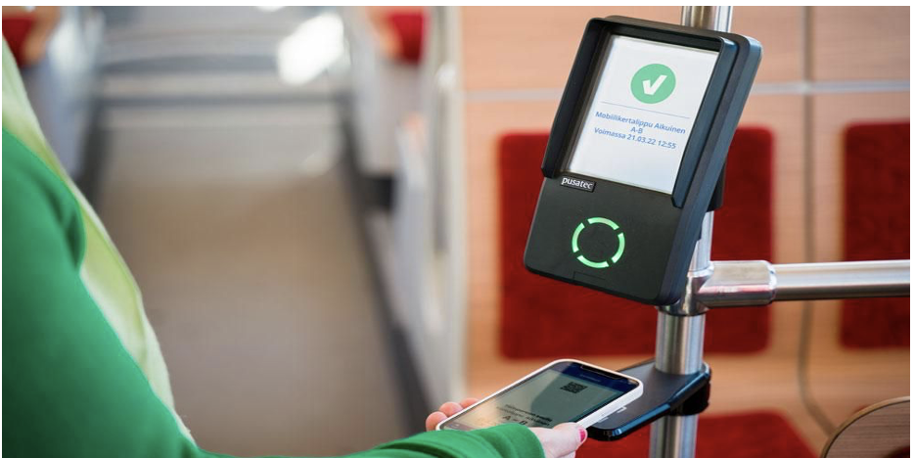

## Payment by Bank Card

If you are paying with a Bank Card, then place your card on the left side as shown in pic.

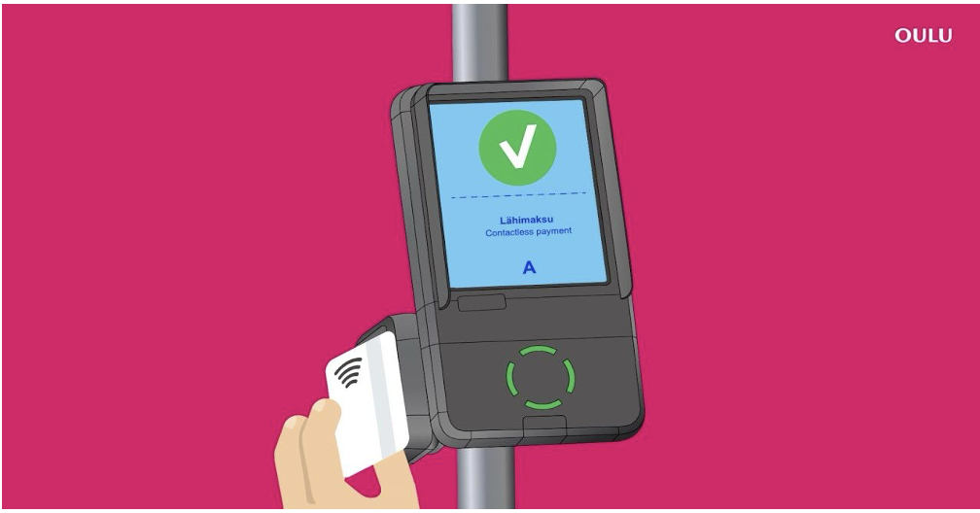

* You can use your Pakistani Mastercard.
* You can download the Revolut/ Wise app and fill in all information using your RP and Finnish Address. Order a virtual card (it is for free) [Don’t order disposable or one-time cards, you can use it only once]. Attach that card to your Google/ apple pay and then you can use your mobile phone for payments. You just have to place your mobile near the machine (as you do with a bank card) and the payment will be deducted. This all may sound difficult but it is very easy and you will get used to it.

## Payment via Nysse Card

If you are paying with a Nysse card, then place your card in front of the machine as shown in the pic.





 